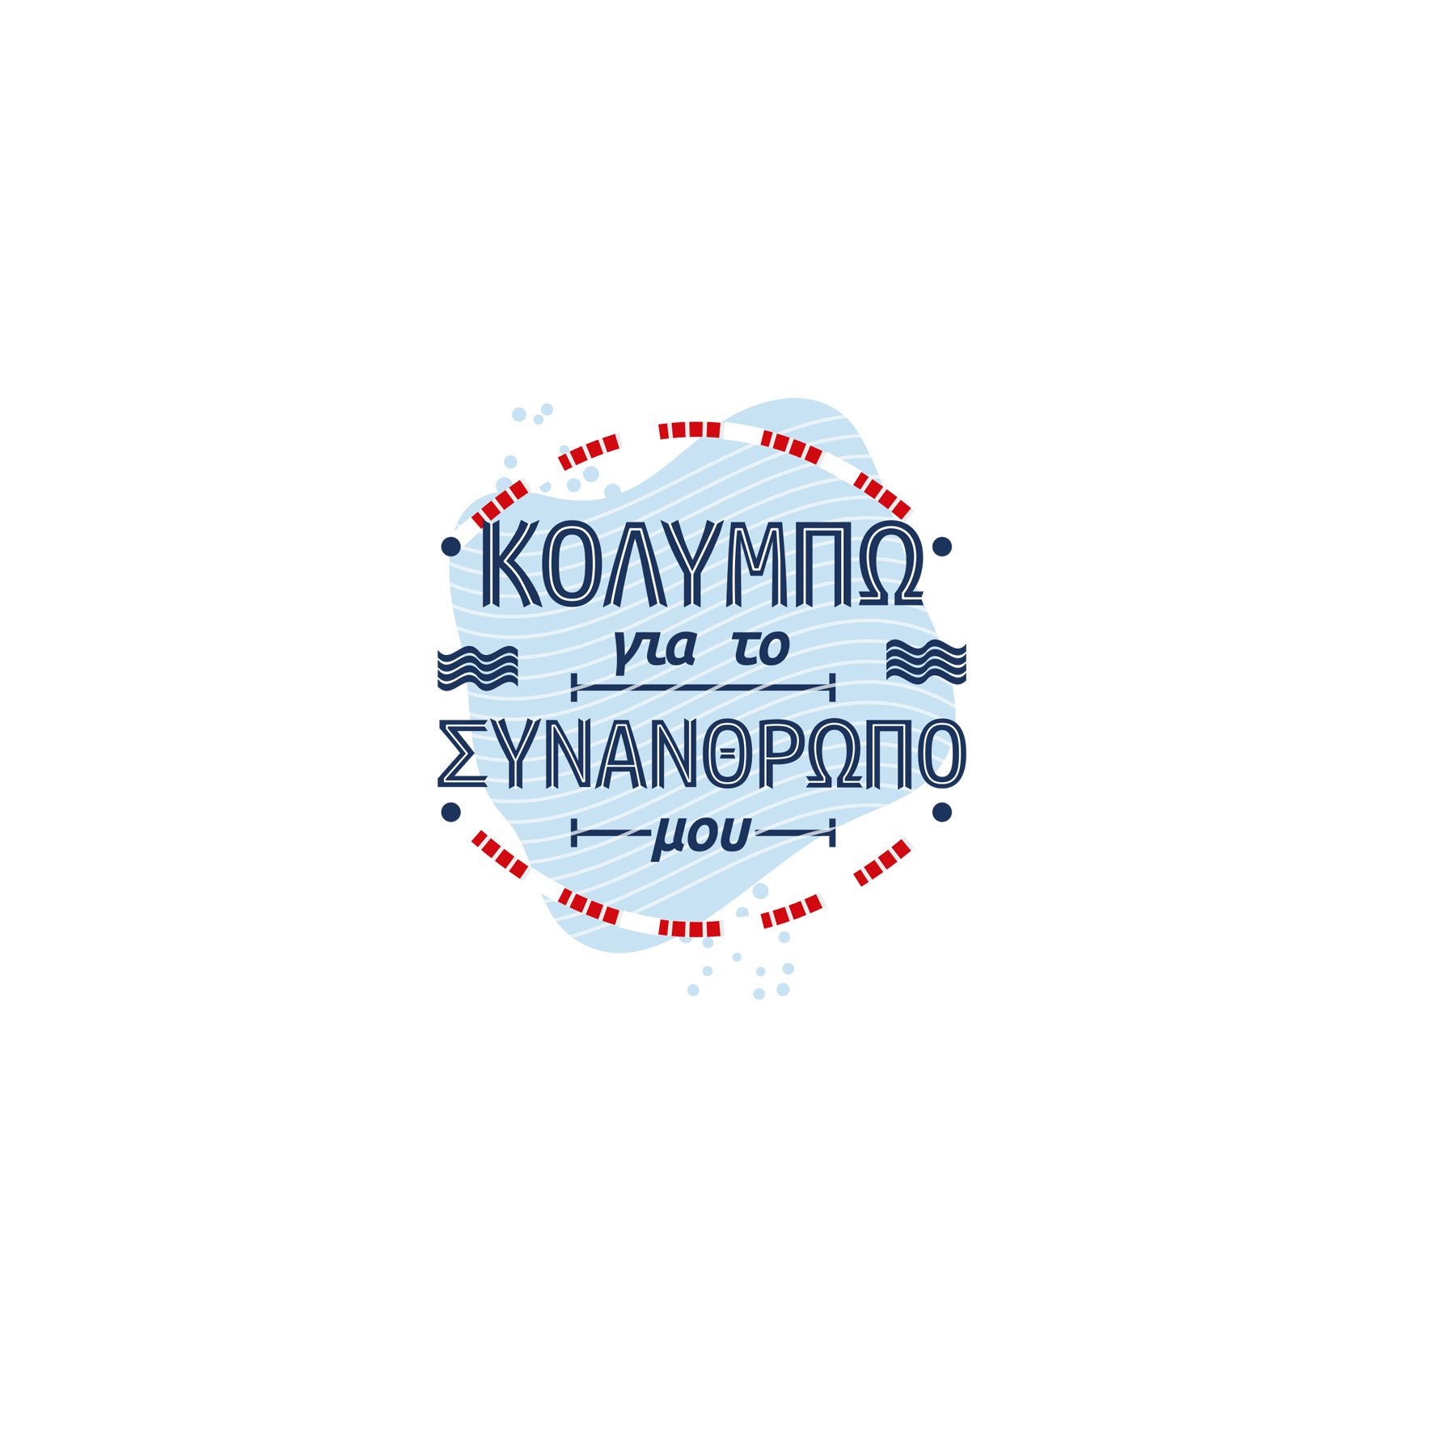

PROGRAMME

9:00 am | Athlete’s Registration
 | Athlete’s numbering
 | Warm Up
9:50am | End of warm Up
9:55πμ | Opening Ceremony
10:00πμ | Start of 1000m Freestyle
 | Award ceremony of 1000m Freestyle
 | Start of 5 X 200m Freestyle Medley
 | Award ceremony of 5 X 200m Freestyle Medley
 | End of the Games

